Practical No. 11
Aim : Write an ALP to find length of a given string

Name : Danish Altaf Solkar Class : CO - B
Enrolment no. : 24111590805 Batch : 2

Code :-

assume cs:code
assume ds:data
data segment
str1 DB "Danish$"
strlength DB ?
data ends
code segment
start:
MOV AX,data
MOV DS,AX
MOV AX,0000H
LEA SI,str1
UP:
MOV AL,[SI]
CMP AL,'$'
JE DOWN
INC SI
INC DL
JMP UP
DOWN:
MOV strlength,DL
INT 03H
code ends
end start

OUTPUT :-

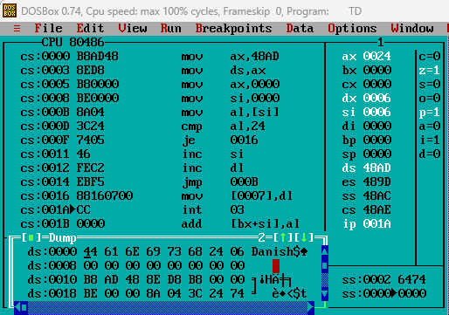

Process related  (15) | Product related  (10) | Total Marks  (25) | Signature

